Griscel Garcia
Professor R. Holcomb
Chemistry 1010
11 December 2017
Signature Assignment: Sodium Chloride
Sodium Chloride? More popularly known as table salt. Is used as a binding agent in skin care products, hair, oral hygiene, shampoo, cleansing, makeup, and bath products. You may wonder why is it doing in our everyday products? Sodium chloride (salt) is used in our everyday products for many different, essential ways. From reducing oral odor to keeping our physiological processes balanced. It is more than just table salt.
Sodium chloride, as known as salt, is an ionic compound with the chemical formula NaCl. It is one of the most abundant minerals on Earth and an essential nutrient for many animals and plants. In the reaction between sodium and chlorine; chlorine has seven electrons in its outer shell. When one atom of chlorine reacts, it will gain one electron from sodium. The outer shell of chlorine will then have 8 electrons and be full. The chloride ion will have an extra electron and therefore an extra negative charge. The force of attraction between the oppositely charged ions is called an ionic bond. The balanced chemical equation for the reaction is
sodium + chlorine = sodium chloride and 2Na (s) + Cl2 (g) = 2NaCl (s).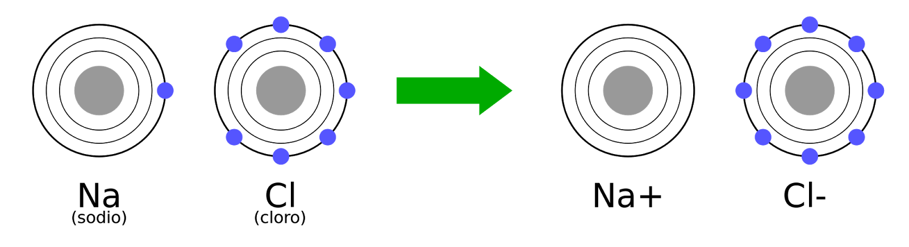
In solid form, salt is a white crystalline solid, found in either two places. It can be mines from ancient sea beds or collected from ponds of seawater. But it is naturally found in seawater and in underground rock formations. It can also be made in a laboratory by the reaction of sodium and chlorine. According to OCR Gateway Science, a website associated with the British Broadcasting Corporation (BBC), said “Salt can be mined by mining solution. This happens in Cheshire in the North West of England. Water is pumped underground and into the salt deposit. Salt dissolves in the water, forming a concentrated salt solution. This is then pumped up to the surface ready for use by the chemical industry.”
Sodium chloride plays an important role of transporting nutrients and waste, nervous system functions, and water and electrolyte balance. According to Chemical Safety Facts, a website dedicated to inform people about the chemistry in our everyday products and how different chemicals are used in products, said “Sodium chloride is essential to maintain the electrolyte balance of fluids in a person’s body. If levels of electrolytes become too low or too high, a person can become dehydrated or overhydrated.”
However, not only does sodium chloride play an important role as a nutrient but also as a preservative and an ingredient in our everyday beauty, oral, skin, and hair products. As an oral product, it polishes the teeth, reduces oral odor, or otherwise cleanses and freshen the teeth and mouth. As a hair product, salt acts as a volumizer and texturizer. The salt in shampoo transforms into micelles which those are what thicken your shampoo. Too much salt in your shampoo just make it thin and runny. In skin care products, salt crystals act as preservatives and exfoliates which remove dead skin cells and unwanted bacteria.
In conclusion, sodium chloride is a very important and essential compound in our lives. From helping us keep our physiological processes balanced to being a preservative for our foods to just being an ingredient added or our self-care products. It is more than just table salt. It’s a chemical compound used in many ways.

Bibliography
“Sodium Chloride .” ChemicalSafetyFacts.org, American Chemistry Council, 22 Sept. 2017. www.chemicalsafetyfacts.org/sodium-chloride/
“Sodium Chloride.” Cosmetics Info, Personal Care Council, 2015. www.cosmeticsinfo.org/ingredient/sodium-chloride-0
“Atomic Structure.” GCSE CHEMISTRY - The Reaction between Sodium and Chloride, GCSE Chemistry, 2015.
www.gcsescience.com/a5-reaction-sodium-chlorine.htm
“GCSE Bitesize: Obtaining Sodium Chloride.” BBC, BBC, 2014. www.bbc.co.uk/schools/gcsebitesize/science/ocr_gateway/chemical_resources/sodium_chloriderev1.shtml.\
“Sodium Chloride.” Sodium Chloride: What Is It?, Ms. Beautyphile, 5 Sept. 2014. www.youtube.com/watch?v=pN68T7ZHHgU

